



**INSTITUTE FOR ADVANCED COMPUTING AND SOFTWARE DEVELOPMENT (IACSD), AKURDI, PUNE**

Documentation On

**FoodEase Online Tiffin Management System**

PG-DAC MARCH 2023

**Submitted By:**

**Group No: 44**

**Roll No: Name:**

**233085 Shashikant Badgujar**

**233147 Bhavesh Chaudhari**

**Mrs. Gauri Kadam Mr. Rohit Puranik**

**Project Guide Centre Coordinator**

# Table of Contents

**Abstract …………………………………….5**

**Acknowledgement …………………………6**

**Introduction ………………………………..7**

**Problem Domain …………………………...8**

**Solution Domain ………………………...…9**

**Requirements**

**1.1 Functional requirements……………..10**

**1.2 Non Functional requirements………..11**

**System Design……………………………..12**

**System Requirement Specification ………13**

**2 System Design**

**2.1 E-R Diagram………………………13**

**2.2 UML Diagrams……………………15**

**2.3 Use Case Diagrams………………..16**

**2.4 Sequence Diagram…………………19**

**2.5 Data Flow Diagrams……………….20**

**2.6 Activity Diagrams………………….23**

**3 Software and Hardware Requirement**

**3.1 Software Requirement……………29**

**3.2 Hardware Requirement………...…..29**

**Purpose of document……………………...30**

**Proposed System…………………………..31**

**Design……………………………………...32**

**Modules…………………………………...34**

**Testing……………………………………..36**

**User Interface……………………………..40**

**2.1 Overview**

**2.2 Study Of the System**

**2.3 Users Of the System**

**2.1.1 Admin**

**2.1.2 Provider**

**2.1.3 User**

**1.4 Security and Authentication**

**1.5 Miscellaneous Feature**

**Future Scope and Limitations……………….47**

**Conclusion…………………………………... 48**

**References ……………………………………49**

# Table of Contents - Diagrams

# E-R Diagram …………..…….………15

# Class Diagram…...………………….. 17

# 3. Use Case Diagram...………………….18

# 3.1 Admin Use Case Diagram

# 3.2 Faculty Use Case Diagram

# 3.3 Student Use Case Diagram

# 4 Sequence Diagram…...……………… 21

# 5 Data Flow Diagrams ………...……….22

# 5.1 Admin Data Flow Diagram

# 5.2 Faculty Data Flow Diagram

# 5.3 Student Data Flow Diagram

# 6 Activity Diagrams…………………….25

# 6.1 Main Flow Diagram……………..23

# 6.2 Admin Activity Diagram………..24

# 6.3 Tiffin provider Activity Diagram25

# 6.4 Customer Activity Diagram…….26

**ABSTRACT**

The FoodEase online tiffin service is a web-based platform that enables customers to order home-cooked meals from local homemakers who run mess services. The main objective of FoodEase is to provide a convenient and efficient way for people to access delicious, home-style meals without the hassle of cooking or eating out. The platform offers a diverse menu, and customers can easily place their order and choose the delivery time that works best for them. Payments are securely processed online. The service is managed by the homemakers who prepare the food, ensuring high quality and authenticity. The platform eliminates the need for intermediaries, directly connecting customers with homemakers who run mess services, and providing an enjoyable and memorable food experience. The objective of the FoodEase online tiffin service is to:

1. Provide a convenient and efficient way for people to access delicious, home-style meals.

2. Offer a diverse menu of home-cooked meals prepared by local homemakers who run mess services.

3. Enable customers to easily place their order and choose a delivery time that works best for them.

4. Securely process payments online.

5. Eliminate intermediaries and directly connect customers with homemakers who run mess services.

6. Ensure high quality and authenticity of the food through direct management by the homemakers.

7. Provide an enjoyable and memorable food experience for customers.

**ACKNOWLEDGEMENT**

I take this occasion to thank God, almighty for blessing us with his grace and taking our endeavor to a successful culmination. I extend my sincere and heartfelt thanks to our esteemed guide**, Mrs. Gauri Kadam** for providing me with the right guidance and advice at the crucial juncture sand for showing me the right way. I extend my sincere thanks to our respected Centre Co-Ordinator **Mr. Rohit Puranik**, for allowing us to use the facilities available. I would like to thank the other faculty members also, at this occasion. Last but not the least, I would like to thank my friends and family for the support and encouragement they have given me during the course of our work.

Shashikant Badgujar (233085)

Bhavesh Chaudhari (233147)

**INTRODUCTION**

FoodEase is a cutting-edge online tiffin service that aims to revolutionize the way people order and enjoy meals. The platform provides customers with access to a diverse menu of home-cooked meals prepared by local homemakers who run mess services. The focus of FoodEase is to make the process of ordering food as convenient and efficient as possible, while also delivering high-quality and authentic meals. FoodEase provides a user-friendly platform that allows customers to easily place their orders online, choose a delivery time that works best for them, and securely process payments through the platform. The service eliminates intermediaries, directly connecting customers with homemakers who run mess services, ensuring that the food they receive is of the highest quality and authenticity. In addition to its focus on convenience and efficiency, FoodEase is committed to providing an enjoyable and memorable food experience for its customers. Whether it's for a quick lunch break or a family dinner, FoodEase offers a range of meal options that are sure to please everyone's taste buds. Overall, FoodEase is a one-of-a-kind online tiffin service that is changing the way people think about ordering and enjoying meals. With its focus on convenience, efficiency, quality, and a memorable food experience, FoodEase is the perfect solution for anyone looking for a convenient and delicious meal.

**PROBLEM DOMAIN**

Till now in urban city most of the people come from other cities or state. Then those people difficult to find daily best meals in nearby and its task is more time consuming for employees. Most of the people is missing homemade foods. even most of the meals providers orders is less popularity even its best meals provider in area. If less order come then maximum food wastage to providers.

**SOLUTION DOMAIN**

The main purpose of this software is that it makes the things easy for the Users as well as Providers. The application provides an online Food to the users or customers. and it helps to provider to Reduce food waste by optimizing inventory and reducing over-purchasing Minimize the chances of spoilage and expiration, saving money on discarded items. Plan meals and recipes based on available ingredients.

Create weekly or monthly meal schedules for customers. Access a database of recipes and suggestions for meals based on available ingredients. We used online application then is time saving for customers to find best meals. For households, enable better communication about meal preferences and dietary needs. Access the system and data from anywhere, making it convenient for users on the go.

**FUNCTIONAL REQUIREMENTS**

1. **User Registration and Authentication:**
   * Users (Admin, Home Mess Owner, Customer) must be able to register and create accounts.
   * The system should authenticate users with secure login methods.
2. **Admin Features:**
   * Admin can view details of Home Mess Owners and Customers.
   * Admin can activate or deactivate accounts.
   * Admin can access information about menus and orders.
3. **Home Mess Owner Features:**
   * Home Mess Owners can update their menu.
   * They can manage orders and delivery status.
   * Broadcast notifications to customers via email or portal.
   * Manage finances and view sales reports.
4. **Customer/User Features:**
   * Customers can place orders from the menu.
   * They can view order status and delivery details.
   * Customers can provide feedback and rate their experience.
   * Edit their profile and manage addresses.
5. **Security & Authentication:**
   * Users should be able to securely log in and log out.
   * User profiles should be viewable and editable.
   * User passwords should be stored securely using Base64 Hashing.
6. **Miscellaneous Features:**
   * Food ordering and delivery tracking features for customers.

**NON-FUNCTIONAL REQUIREMENTS**

* **Usability Requirement Registration**

User and Provider can register oneself by filling the signup form and perform own particular task.

* **Security**

User authentication and authorization should be implemented to ensure that only authorized users can access certain features or data.

User passwords should be securely hashed and stored to protect user data from      unauthorized access.

sensitive user data, such as payment information, should be encrypted during     transmission and storage.

* **Session Management:**

We can store user-related information in a session in form of key and value pairs. The HTTP Session interface defines the setAttribute(key, value) method to store a key-value entry and getAttribute(key) method to get value of a specified key.

As user login, user Id is stored in session storage and by using this user Id we can handle individual functionalities and display the data related to particular user.

As user logout from ones respective profile, the Id stored in session storage get deleted automatically.

Due to session management, if anyone tries to access the details of any user directly through then page directly renders to the homepage and by this way we achieved, security with the help of session management.

SYSTEM DESIGN

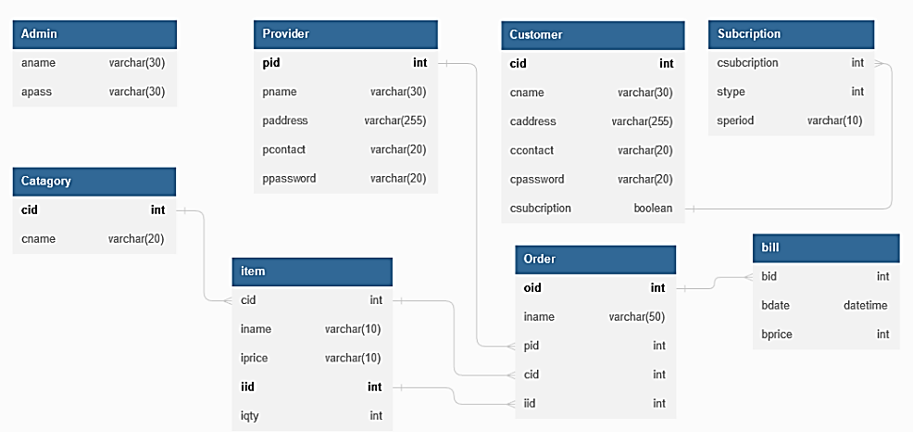

ER DIAGRAM

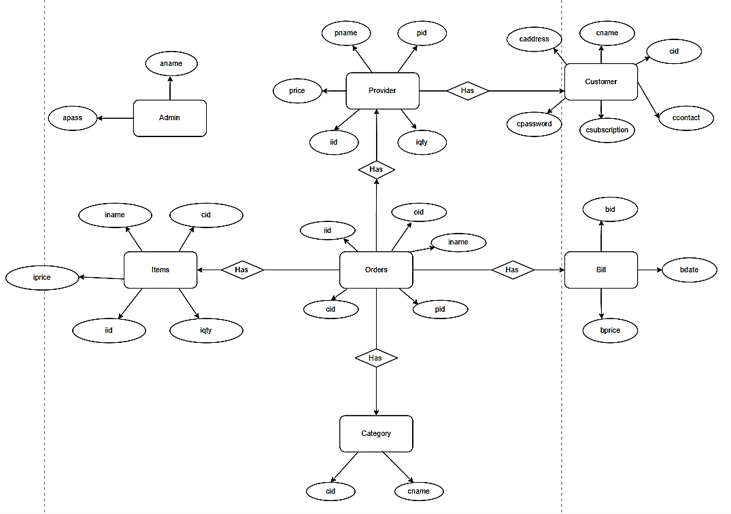

M

1

M

1

M

1

M

1

M

MySQL Workbench generated Entity Diagram

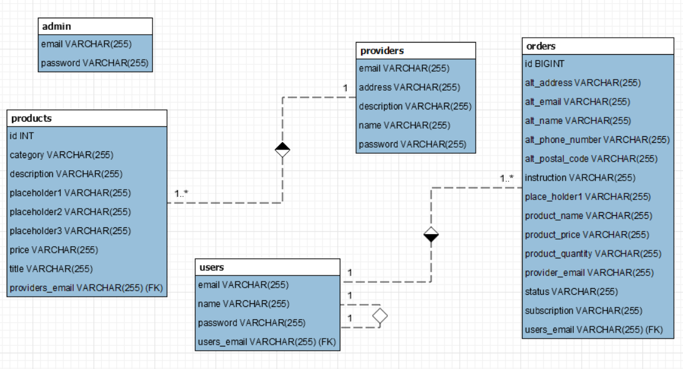

**UML DIAGRAMS UNIFIED MODELING LANGUAGE DIAGRAMS**

The unified modeling language allows the software engineer to express an analysis model using the modeling notation that is governed by a set of syntactic semantic and pragmatic rules. A UML system is represented using five different views that describe the system from distinctly different perspective. Each view is defined by a set of diagrams, which is as follows.

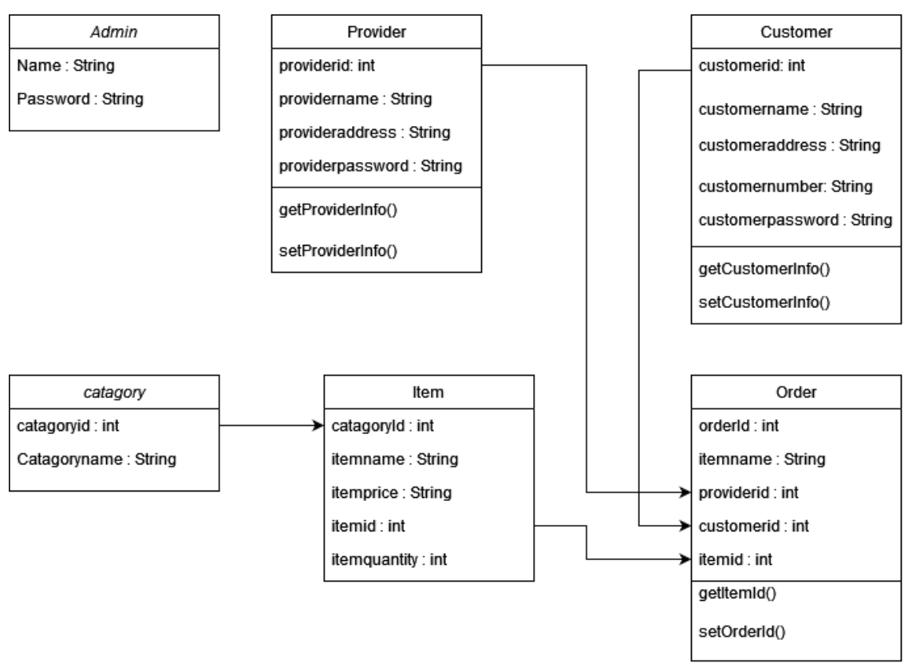**CLASS DIAGRAM**

**USE CASE DIAGRAMS**

System (Base Level) UCD:

1. Admin

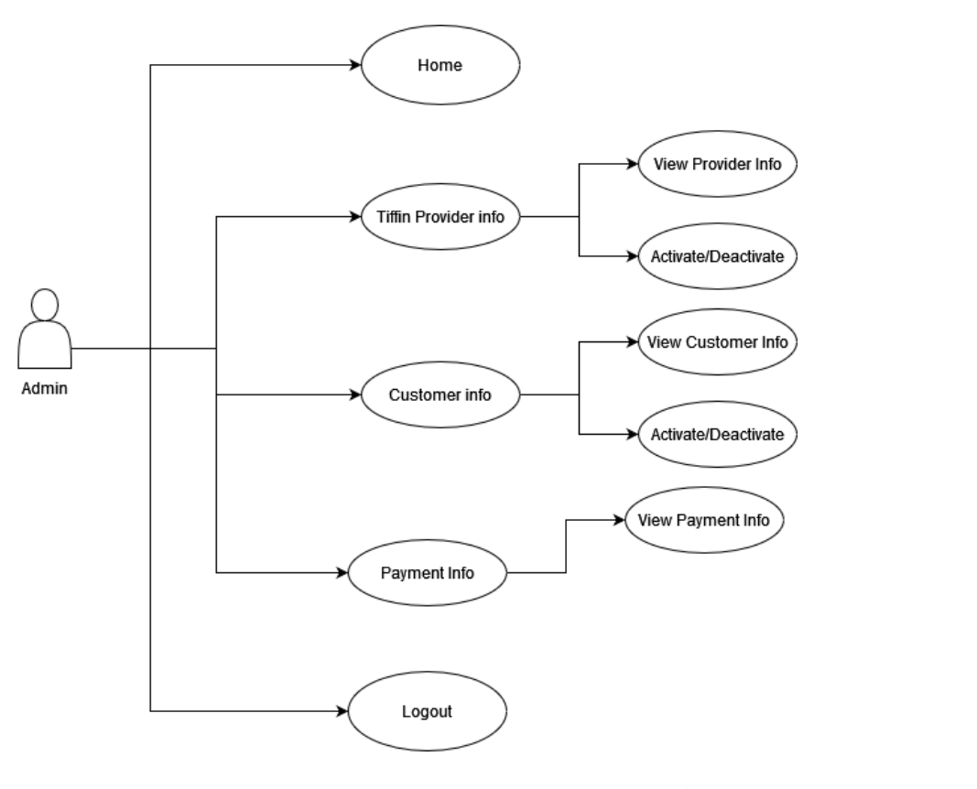

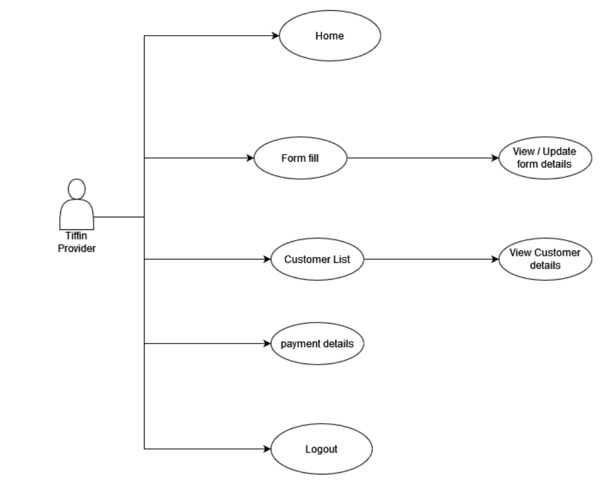2. Tiffin Provider

3. Customer/User

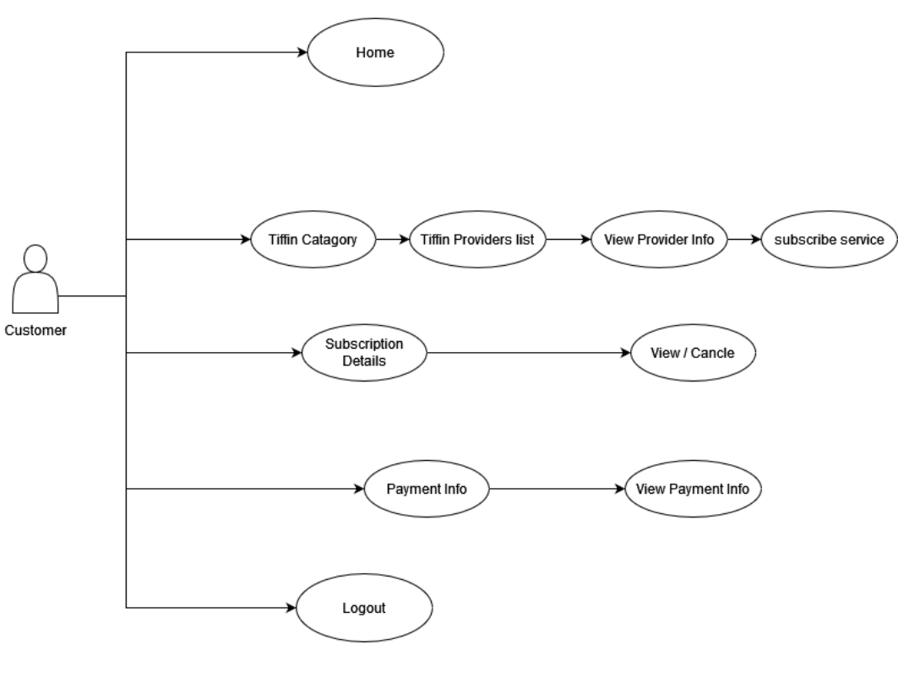

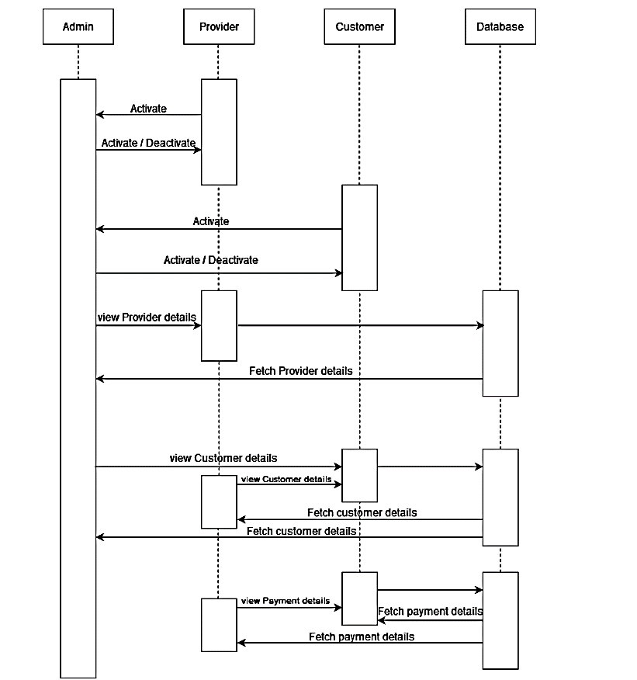**SEQUENCE DIAGRAM**

**DATA FLOW DIAGRAM**

1. Admin DFD

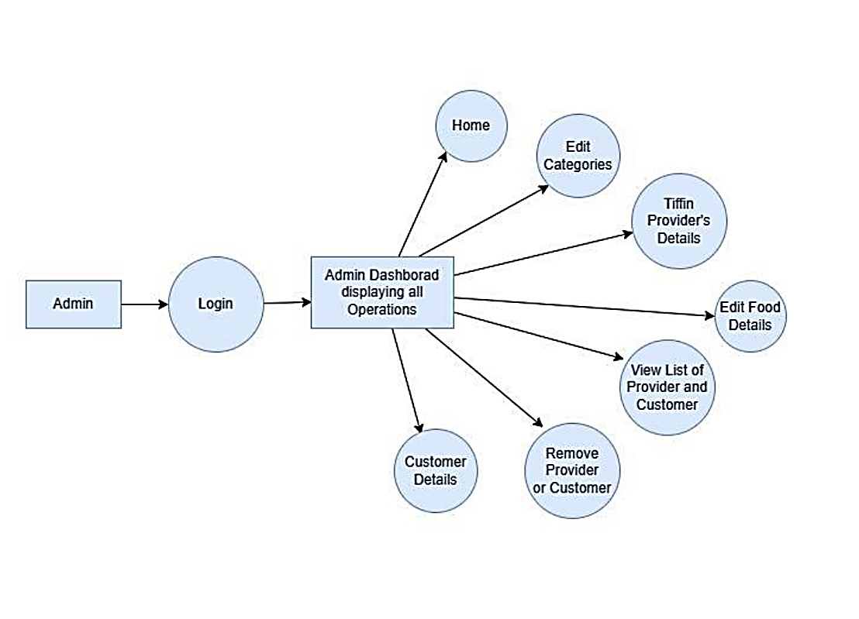

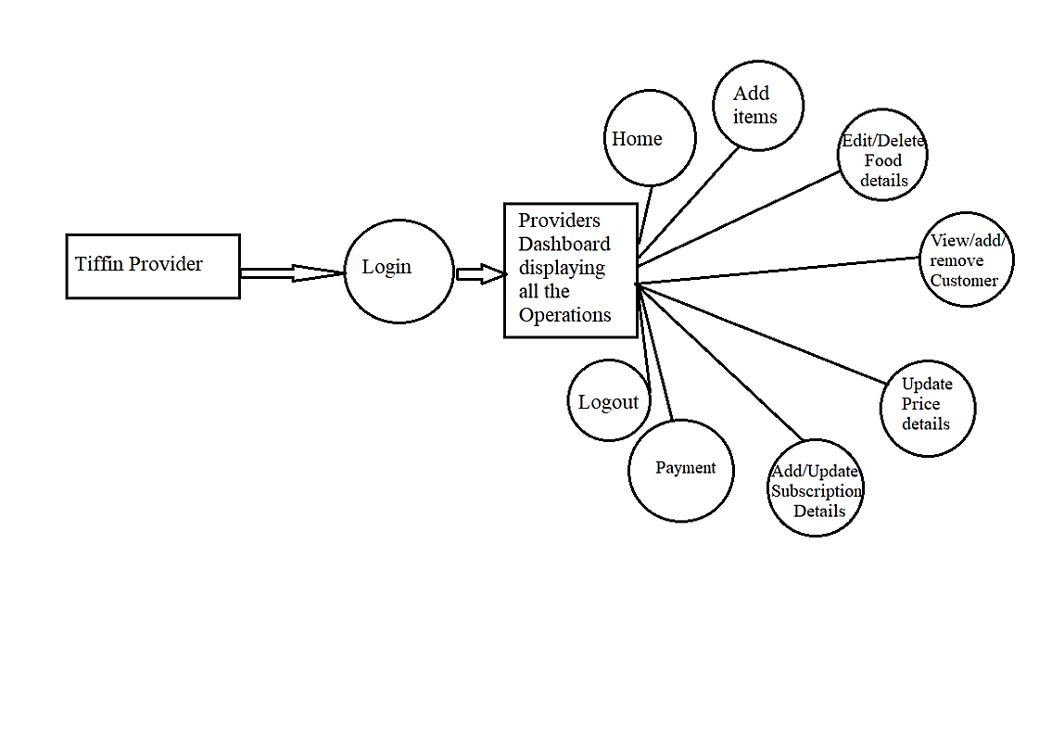2. Tiffin provider DFD

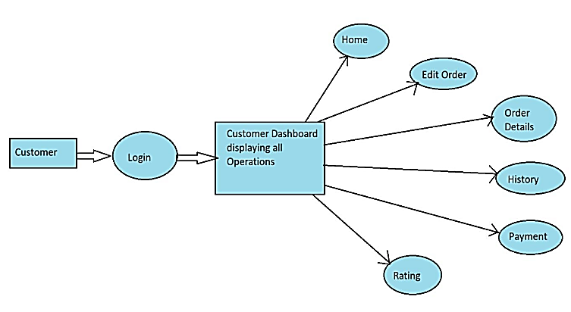3. Customer/User DFD

**ACTIVITY DIAGRAM**

* **Main Flow Diagram**

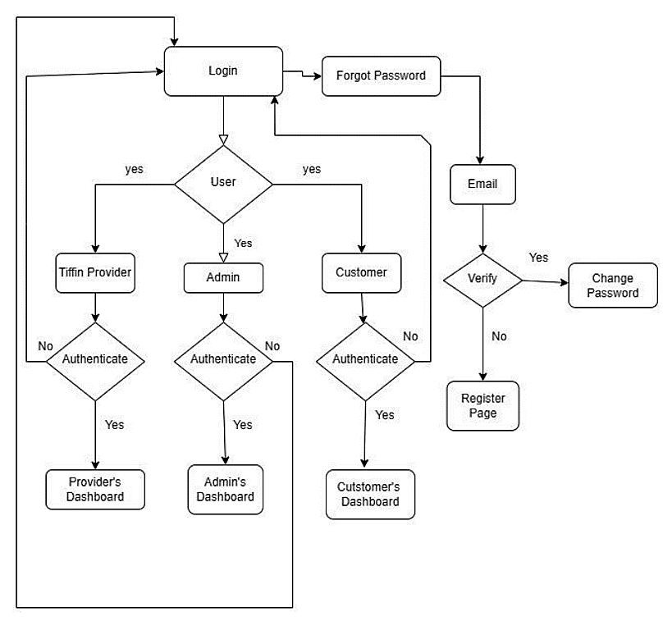

* **Admin Activity Diagram**

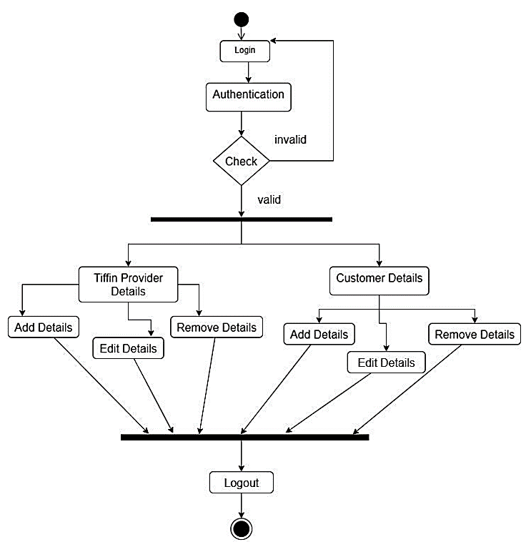

* **Tiffin Provider Activity Diagram**

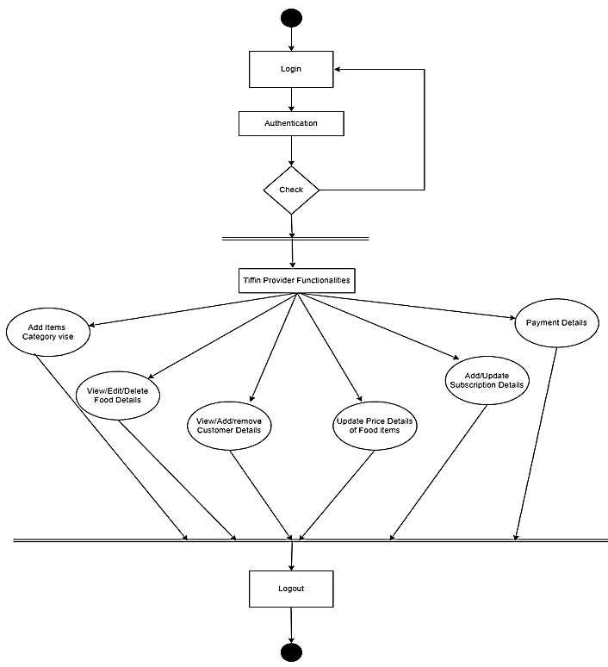

* **Customer Activity Diagram**

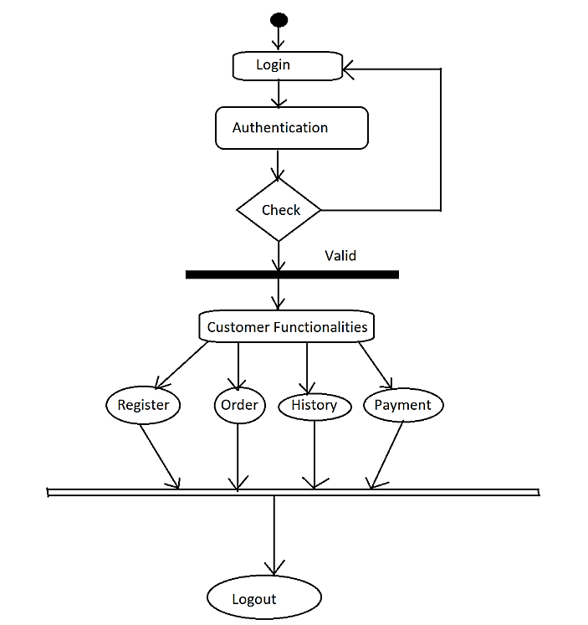

**Technologies Used**

**React Js (18.2.0):**

React is a declarative, efficient, and flexible JavaScript library for building user interfaces. It lets you compose complex UI’s from small and isolated pieces of code called “components”. React is a JavaScript library for building user interfaces. React is used to build single page applications. React allows us to create reusable UI components. All the front end was completed with the help of React.

**MySQL (8.0):**

MySQL is a relational database management system based on the Structured Query Language, which is the popular language for accessing and managing the records in the database. MySQL is open-source and free software under the GNU license. All the User's data which is part of Hospital management system is managed with the help of MY-SQL.

**Spring Tool Suite (3.9.18):**

Spring Tool Suite is an IDE to develop Spring applications. It is an Eclipse-based development environment. It provides a ready-to-use environment to implement, run, deploy, and debug the application. It validates our application and provides quick fixes for the applications. With the help of Spring tool suite, we created a Spring Boot project from Eclipse and used it for the developing the back-end part.

**VS Code (1.81):**

Visual Studio Code is a streamlined code editor with support for development operations like debugging, task running, and version control. It aims to provide just the tools a developer needs for a quick code-build-debug cycle and leaves more complex workflows to fuller featured IDE’s, such as Visual Studio IDE With the help of VS Code, we created a react js project and used it for the developing the front-end part.

**Git Lab**

GitLab is a web-based Git repository that provides free open and private repositories, issue-following capabilities, and wikis. It is a complete DevOps platform that enables professionals to perform all the tasks in a project—from project planning and source code management to monitoring and security. All the project source code and documentation version control as well as management was done using Git Lab.

**SYSTEM ANALYSIS**

The Proposed FoodEase Online Tiffin Service has the following

features:

1. Secure registration and login system for customers and homemakers.

2. Easy-to-use online ordering system for customers.

3. Diverse menu of home-style meals prepared by local homemakers.

4. Convenient delivery scheduling options for customers.

5. Secure online payment processing.

6. Direct connection between customers and homemakers for quality

assurance.

7. Customer reviews and ratings system for homemakers.

8. Order tracking and delivery confirmation.

9. Easy access to homemaker's information, including cooking

experience and specialties.

10. Admin control for managing customer and homemaker accounts,

monitoring orders, and resolving issues

**System Requirements and Hardware Requirements**

Software Requirements:

• Technology: J2SE and J2EE, Hibernate Spring Boot

• Web-Technologies: React, CSS, JavaScript

• Web Server: Tomcat 9.0

• Java Version: JAVA Version 11

• Backend Database: MySQL 8.0

• IDE: Eclipse

Hardware Requirements (Minimum):

• Processor: Pentium IV

• RAM Capacity: 1GB

• Hard Disk: 160GB

**PURPOSE OF DOCUMENT**

The purpose of this document is to outline the software requirements and

specifications for the ‘FoodEase Online Tiffin Service’. This platform aims

to provide customers with a convenient and efficient way to order high quality, home-style meals prepared by local homemakers.

The document is intended for developers, testers, project managers, and stakeholders to understand the design of the system and its various components. It outlines the functionalities, features, and characteristics of the system, as well as the working environment and non-functional requirements. The document also includes information on the user interface security features, and external interface requirements, among other aspects of the system.

**PROPOSED SYSTEM**

To provide a platform for customers to order home-style meals from local homemakers. Only accessible after registering on the website. To provide interaction between customers and homemakers. Customers can view menu options and place orders. Homemakers can interact directly with customers for any clarifications or special requests. The main objective of this system is to provide a convenient and efficient solution for customers to access quality home-style meals, and for homemakers to reach a wider audience and manage their business efficiently.

**DESIGN**

* DATA MODEL

|  |  |
| --- | --- |
| Admin Table | |
| email (PK) | password |

|  |  |  |  |  |
| --- | --- | --- | --- | --- |
| Providers Table | | | | |
| name | address | description | email(PK) | password |

|  |  |  |
| --- | --- | --- |
| Users Table | | |
| email | name | password |

Orders Table

+------------------+--------------+------+-----+---------+----------------+

| Field | Type | Null | Key | Default | Extra |

+------------------+--------------+------+-----+---------+----------------+

| id | bigint | NO | PRI | NULL | auto_increment |

| alt_address | varchar(255) | YES | | NULL | |

| alt_email | varchar(255) | YES | | NULL | |

| alt_name | varchar(255) | YES | | NULL | |

| alt_phone_number | varchar(255) | YES | | NULL | |

| alt_postal_code | varchar(255) | YES | | NULL | |

| instruction | varchar(255) | YES | | NULL | |

| place_holder1 | varchar(255) | YES | | NULL | |

| product_name | varchar(255) | YES | | NULL | |

| product_price | varchar(255) | YES | | NULL | |

| product_quantity | varchar(255) | YES | | NULL | |

| provider_email | varchar(255) | YES | | NULL | |

| status | varchar(255) | YES | | NULL | |

| subscription | varchar(255) | YES | | NULL | |

| users_email | varchar(255) | YES | MUL | NULL | |

+------------------+--------------+------+-----+---------+----------------+

Products Table

+-----------------+--------------+------+-----+---------+----------------+

| Field | Type | Null | Key | Default | Extra |

+-----------------+--------------+------+-----+---------+----------------+

| id | int | NO | PRI | NULL | auto_increment |

| category | varchar(255) | YES | | NULL | |

| description | varchar(255) | YES | | NULL | |

| placeholder1 | varchar(255) | YES | | NULL | |

| placeholder2 | varchar(255) | YES | | NULL | |

| placeholder3 | varchar(255) | YES | | NULL | |

| price | varchar(255) | YES | | NULL | |

| title | varchar(255) | YES | | NULL | |

| providers_email | varchar(255) | YES | MUL | NULL | |

+-----------------+--------------+------+-----+---------+----------------+

**MODULES**

The system comprises of 2 major modules with their sub-modules as follows:

**1.**  **New Provider Registration:**

* 1. **Provider Login:** If provider not registered yet it first signs up by using email and password.
  2. **Password:** The Login Credentials entered by the Provider to log in.
  3. **Home page:** Every admin, user and provider can see same home page.
  4. **Add Product:** After login go to add product and filled all instruction about products.
  5. **Product Page:** After login go to product page and can view particular product details and provider can edit and save particular products.
  6. **Alert Page**: After login go to alert page and can view particular product details is pending and closed. Provider can accept the user product request and closed it.
  7. **Contact Us**: In this page include information about the application, delivery time and contact details etc.

1. **New User Registration:**
   1. **Registration:** User can register his detail.
   2. **Login:** User Login his account.
   3. **Home Page:** User home page can show order now and order history options as well as all popular food if user want to cart specific foods.
   4. **Meals Page**: This page show all the foods which are provided by providers and as own choice to cart specific foods.
   5. **Cart Page**: In this page which foods user click to cart then these details show in cart page with price.
   6. **Contact Us**: In this page include information about the application, delivery time and contact details etc.

**MODULES**

1. **Bell Icon** : In this page show user foods with status its pending or closed.

h. **Cart Icon** : In this page show user click which foods.

**3**. **Admin**:

1. **Home page:** Every admin, user and provider can see same home page.
2. **Providers page:** In admin page show all providers products and admin can access to delete providers.
3. **Contact us:** In this page include information about the application, delivery time and contact details etc.

**TESTING**

The report of the testing is given here

|  |  |  |  |  |
| --- | --- | --- | --- | --- |
| **SR- NO** | **TEST CASE** | **EXPECTED RESULT** | **ACTUAL RESULT** | **ERROR MESSAGE** |
| 1 | Provider Register Page | Redirected to login page | OK | Nothing |
| 2 | Login Page | Pop-up will come | OK | Invalid credentials |
| 4 | Add Food without filled details | Show error message as “Filled First” | OK | Show error message as “Filled First” |
| 5 | Add Food | Food Added | OK | Nothing |
| 6 | Product Page | Show added Meals | OK | Nothing |
| 7 | Edit meals button | Is Clickable | OK | Nothing |
| 8 | Edit Meals | Meals edit successfully | OK | Nothing |
| 9 | Delete button | Meal delete successfully | OK | Nothing |

|  |  |  |  |  |
| --- | --- | --- | --- | --- |
| 10 | Alert Page | Show Pending and Closed. | OK | nothing |
| 11 | Test Pending and Closed button clickable | It Should be Clickable | OK | Invoice already created |
| 12 | Test Provider Logout button | It should be clickable and logout provider. | OK | Create invoice first |
| 13 | Test User Login without enter details | give error message “Please filled first” | Ok | give error message “Please filled first” |
| 14 | Test User Login | Redirected to login page | Ok | Nothing |
| 15 | Login Page | Pop-up will come | OK | Invalid credentials |
| 16 | Test Order Now button | It Clickable | ok | Noting |
| 17 | Test add to cart | Meals add in cart | ok | Nothing |
| 18 | Test Cart icon | Its Clickable | ok | Nothing |

|  |  |  |  |  |
| --- | --- | --- | --- | --- |
| 19 | Test Cart Icon | Show added cart meals | ok | Nothing |
| 20 | Test Cart Page | it displays added meals in cart with price | Ok | Nothing |
| 21 | test Continue shopping button if not added meals | its redirect to shopping meals | Ok | Nothing |
| 22 | Test Proceed to checkout | it redirects to Payment page | ok | Nothing |
| 23 | Click Payment If not filled details | It not redirect page | Ok | Nothing |
| 24 | Test Payment button | Payment successfully | Ok | Nothing |
| 25 | Test User Logout | Logout Successfully | Ok | Nothing |
| 26 | Test Admin Login | Redirected to login page | Ok | Nothing |
| 27 | Test Admin Login without enter details | give error message “Please filled first” | Ok | give error message “Please filled first” |

|  |  |  |  |  |
| --- | --- | --- | --- | --- |
| 28 | Test Home Page UI | It should be clear to vision | Ok | Nothing |
| 29 | Test Providers Page | It redirects to provider page | Ok | Nothing |
| 30 | Test to show all meals | Show all provider meals | Ok | Nothing |
| 31 | Test provider delete button | Provider should delete successfully | Ok | Nothing |
| 31 | Test Admin Logout | It redirects to Home page | Ok | Nothing |

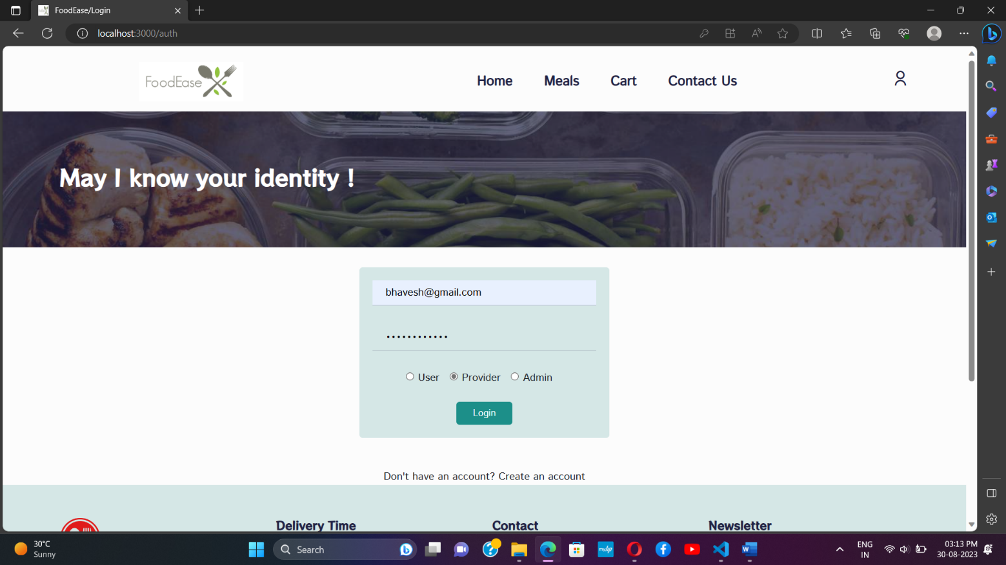**USER INTERFACE**

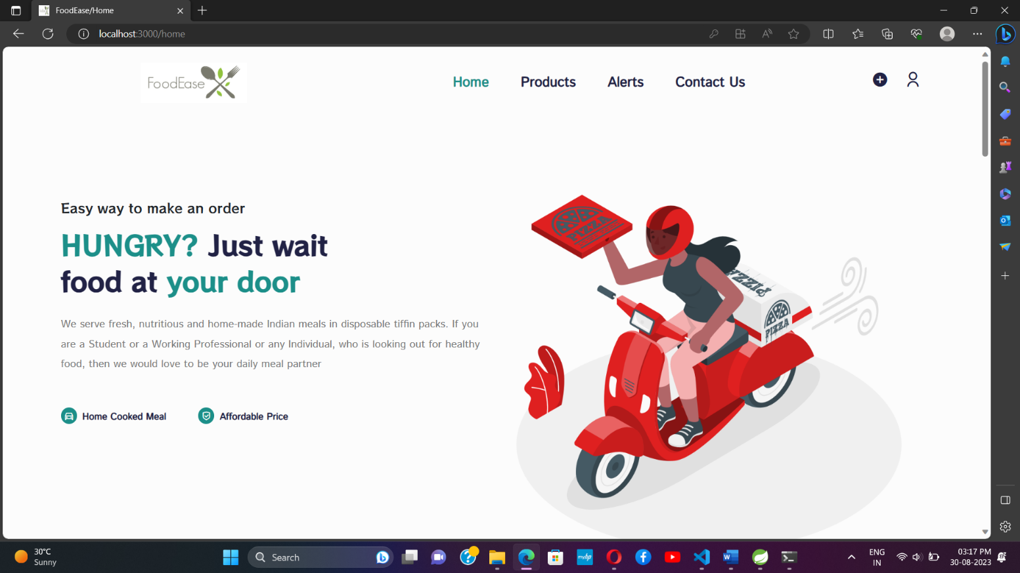Register User or Provider

Home Page

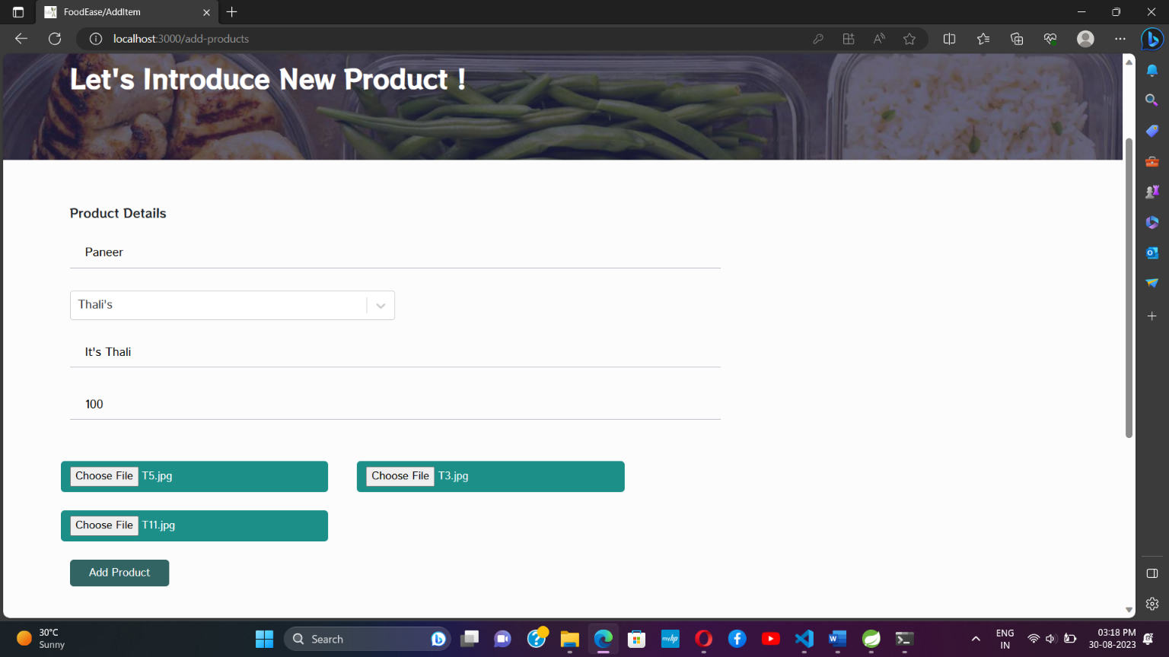

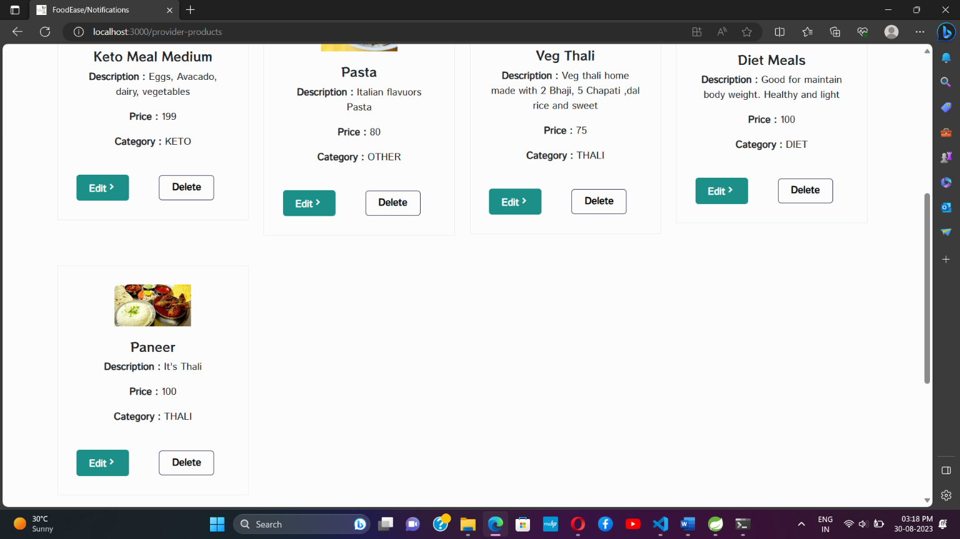 Create Food Menu Dishes

Manage Dishes

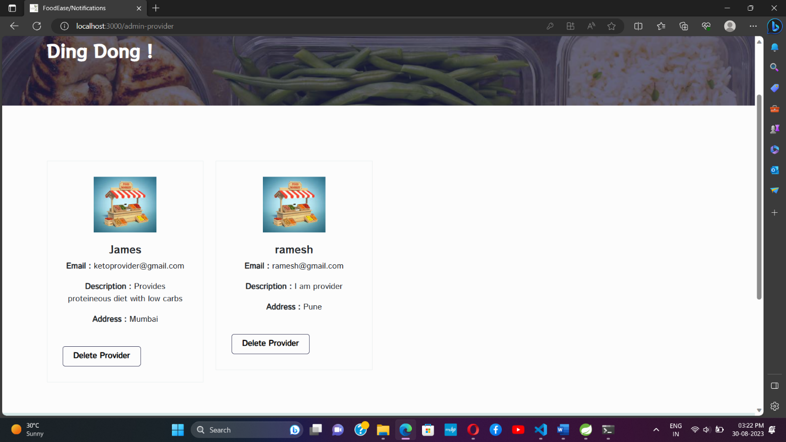

Admin Controlled page

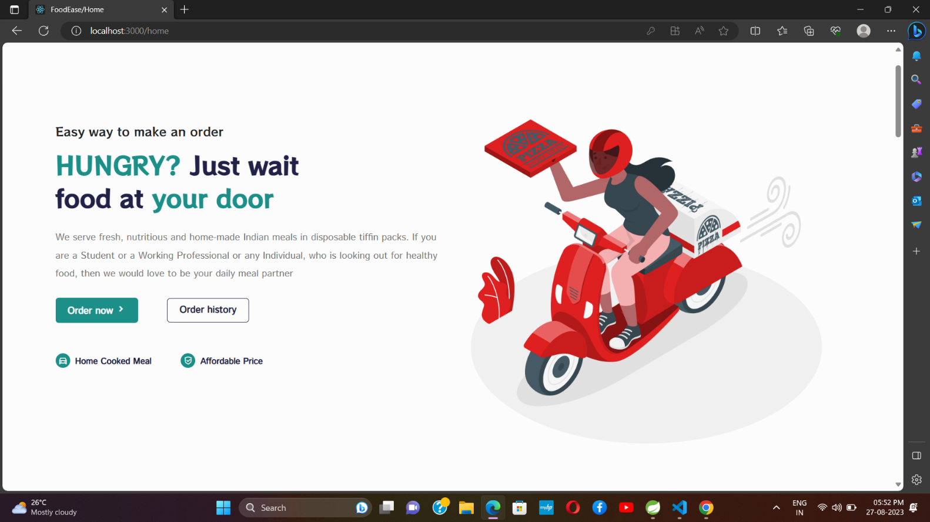

Ordering meal

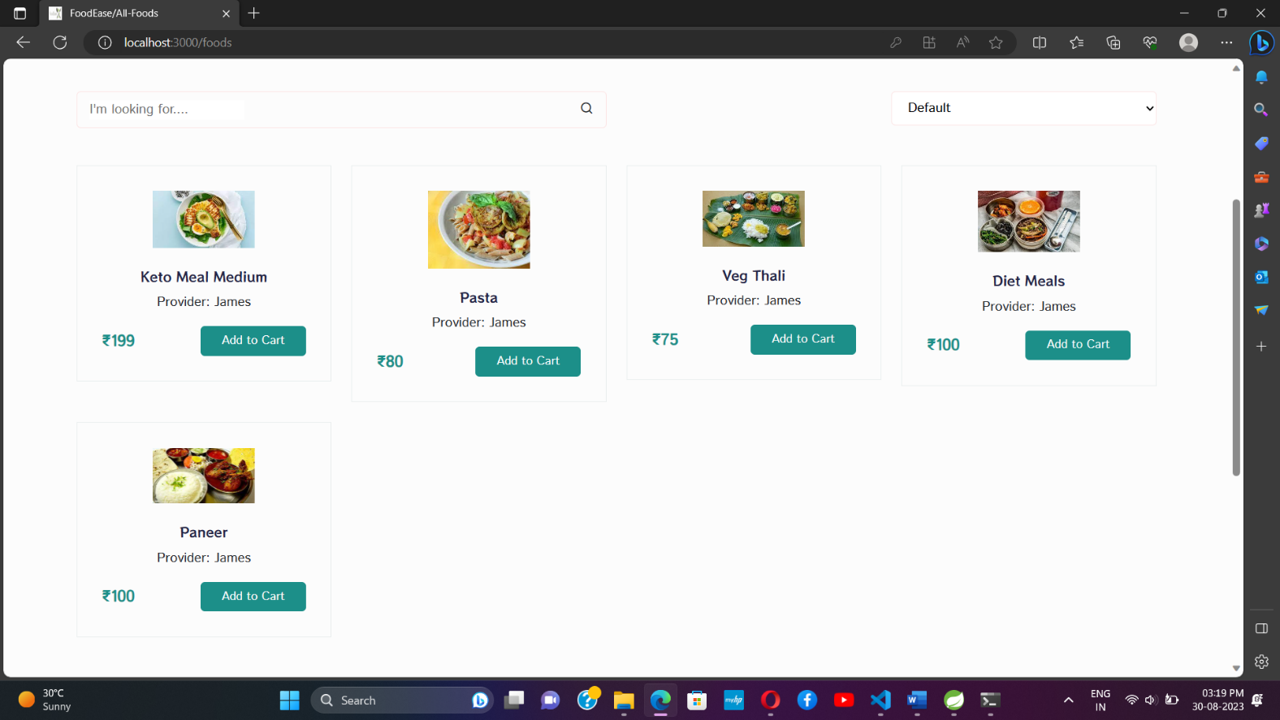

Product List

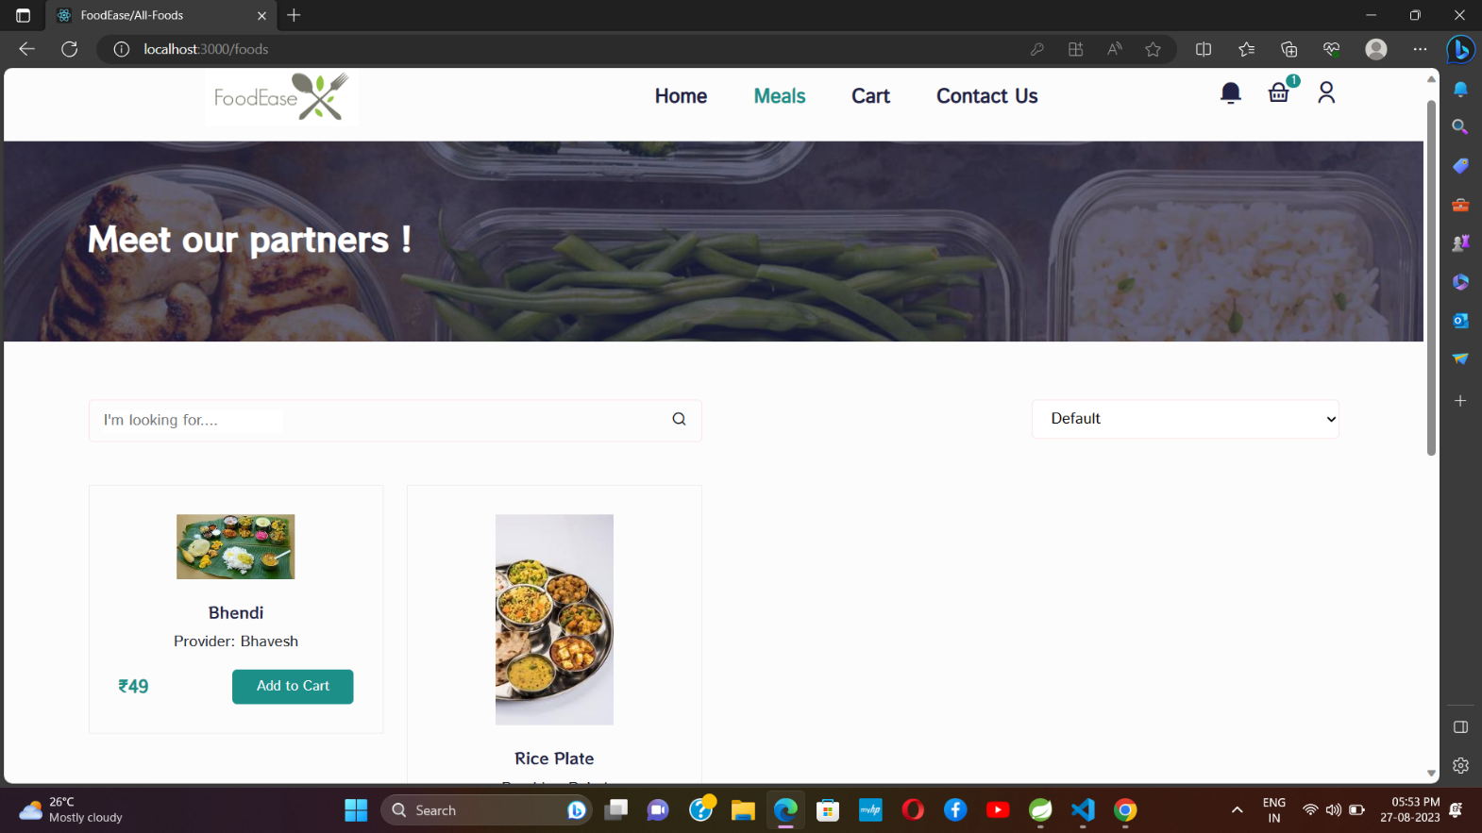

Item added into cart

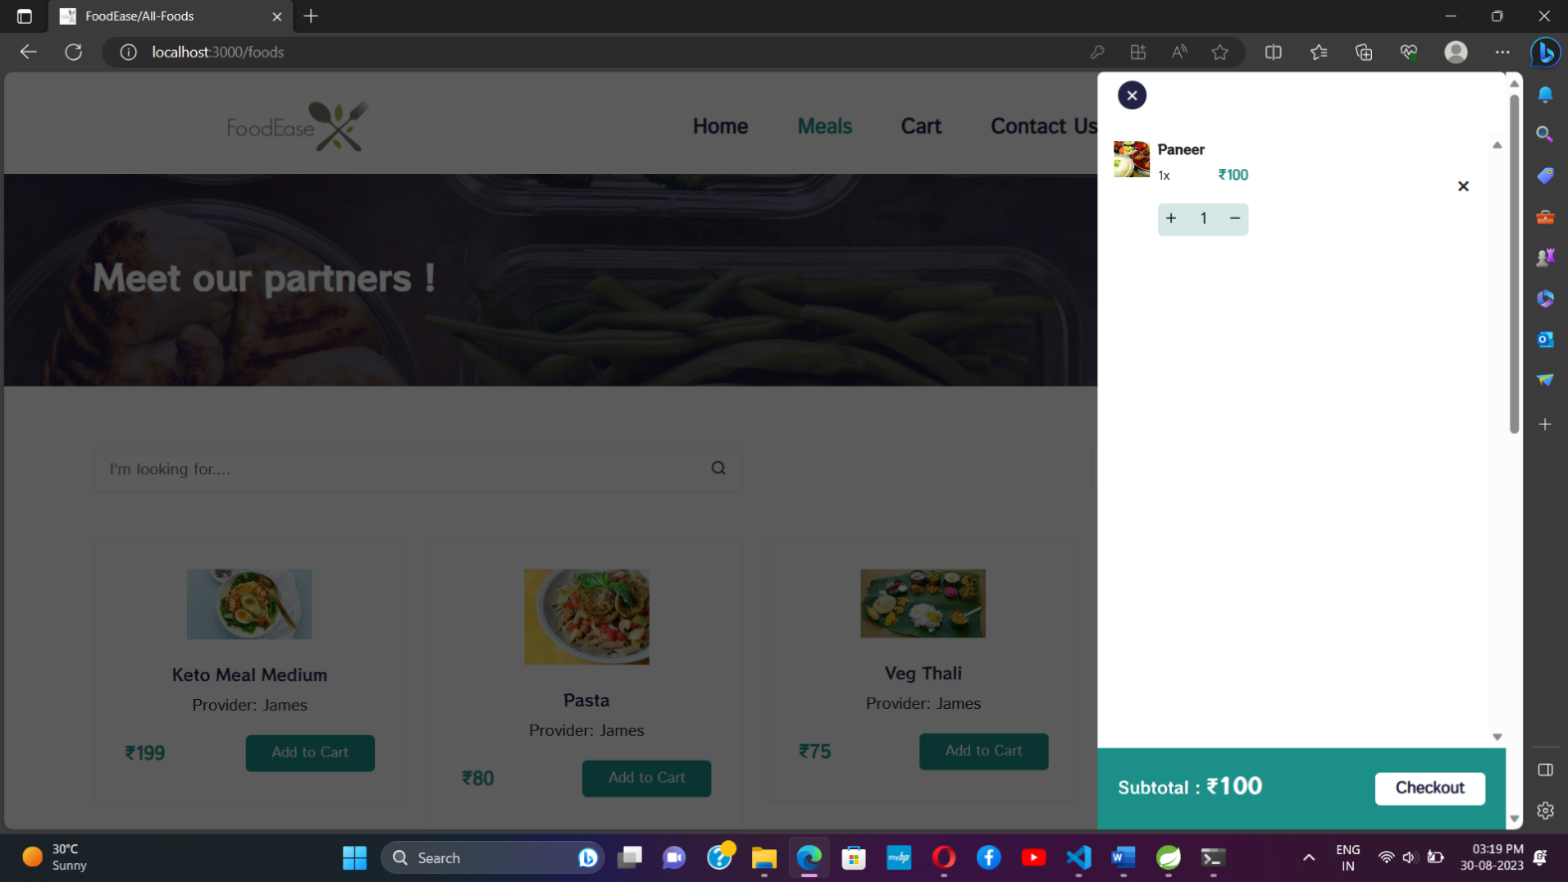

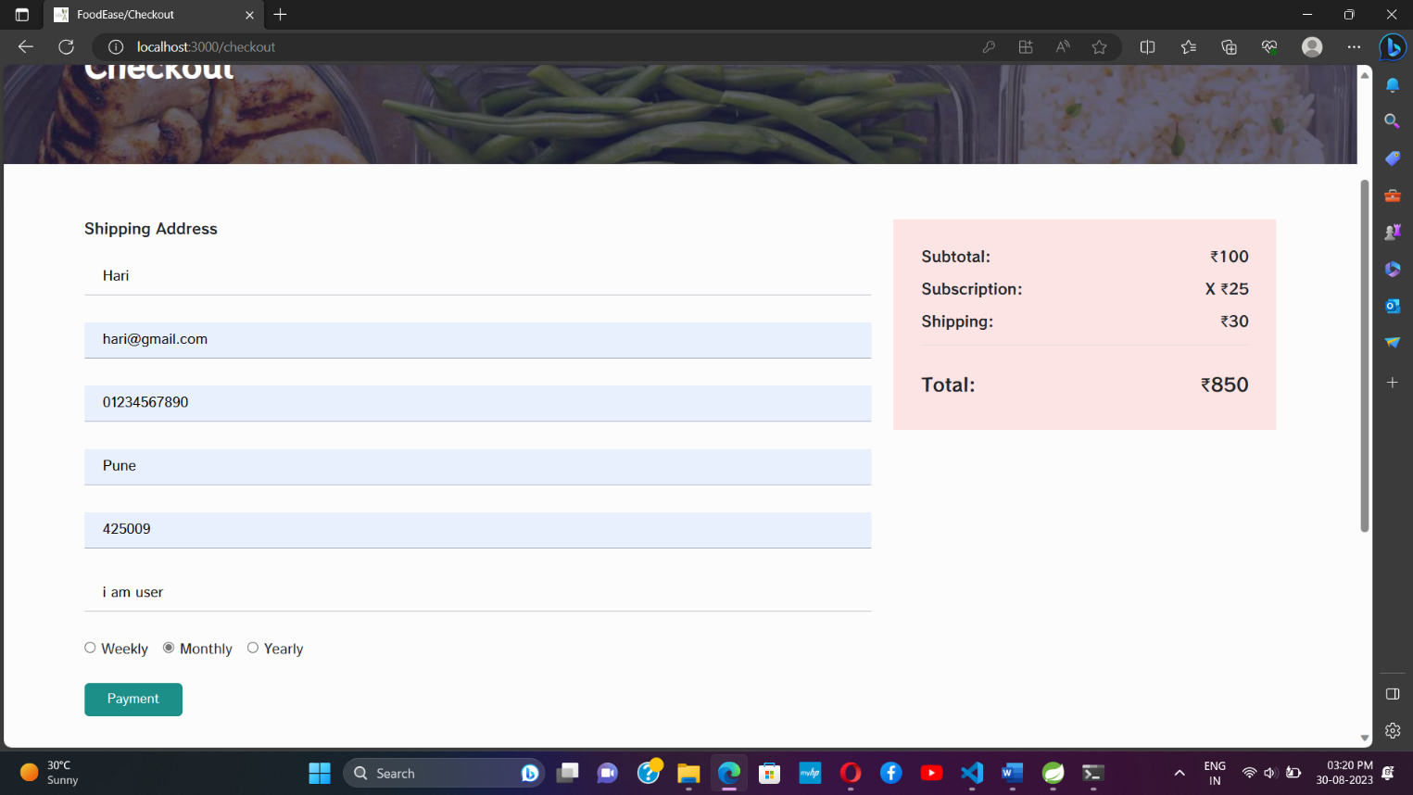

Payment page

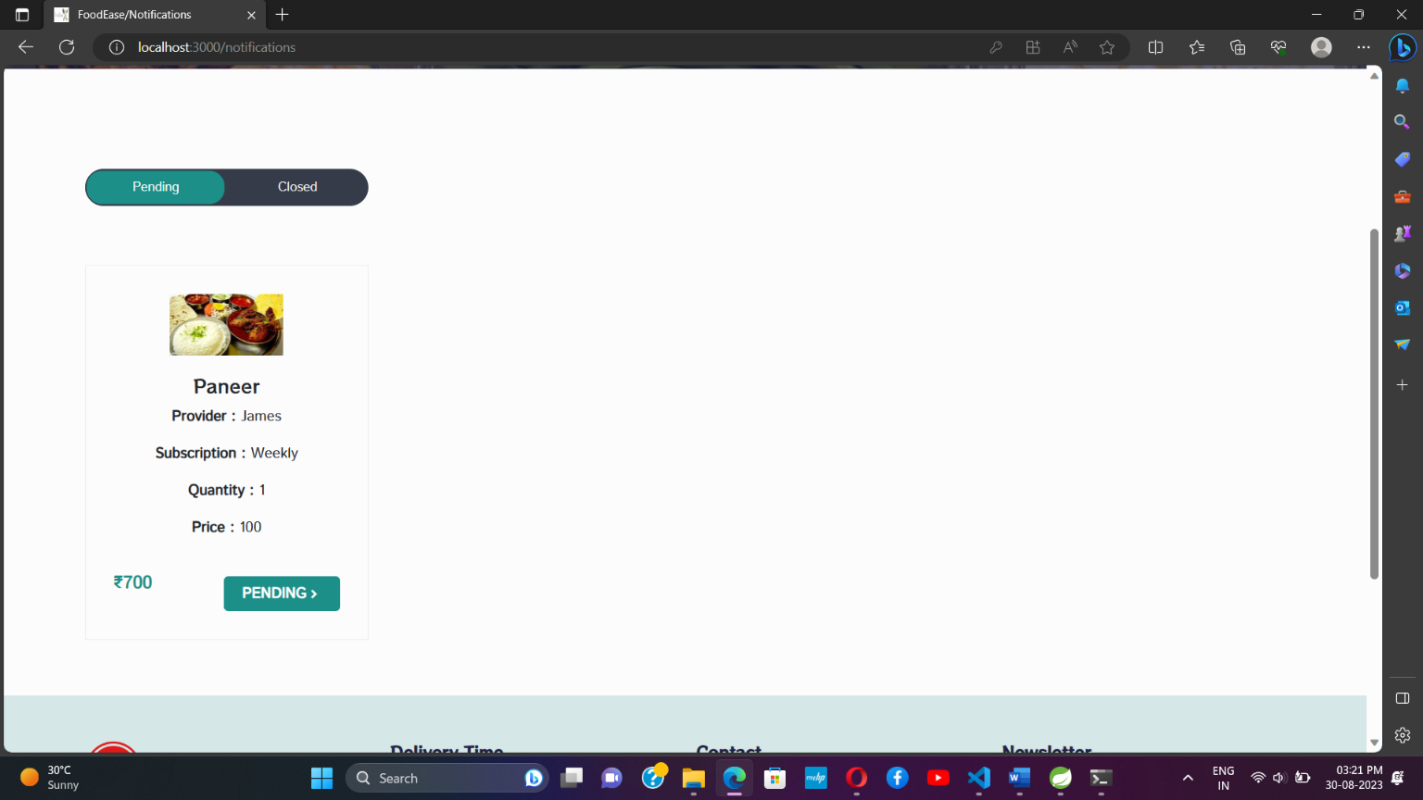

Order approval by provider

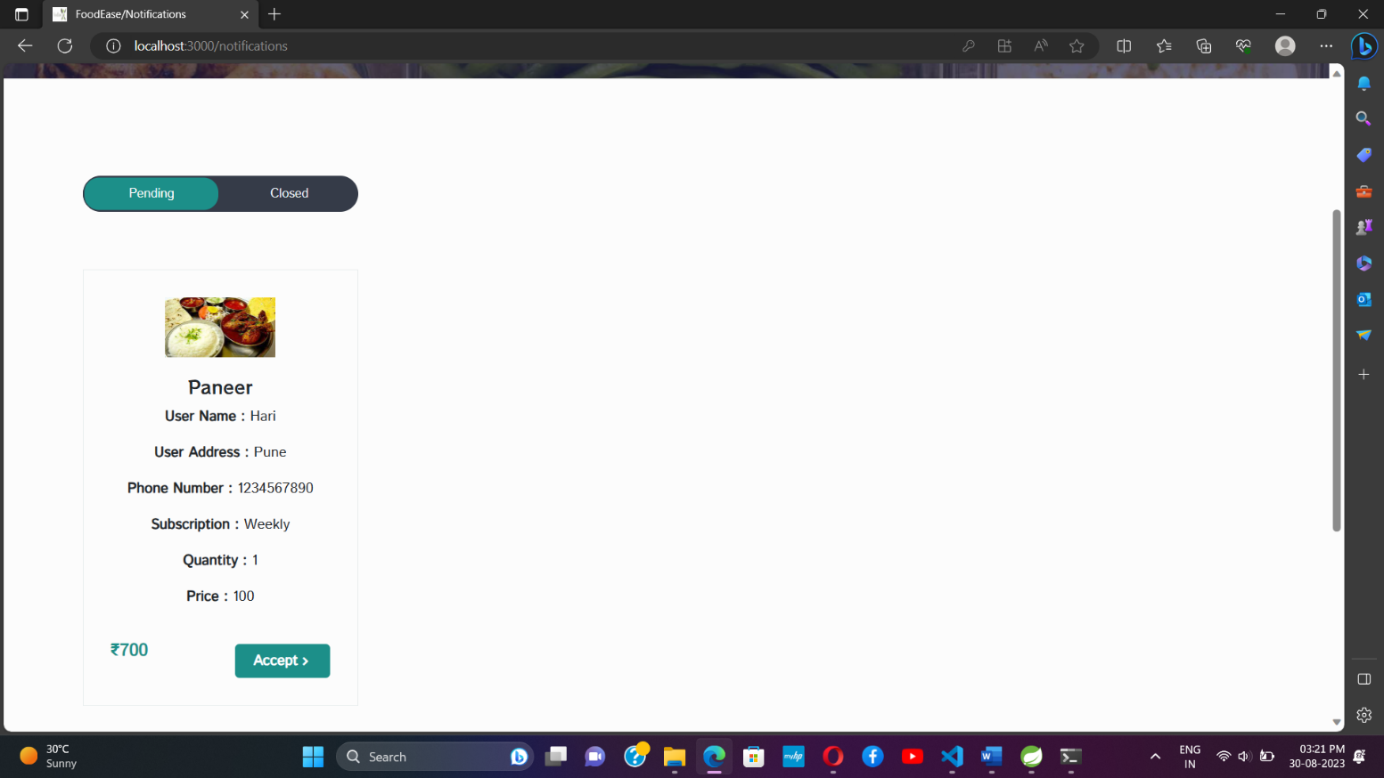

Changing status from pending to closed

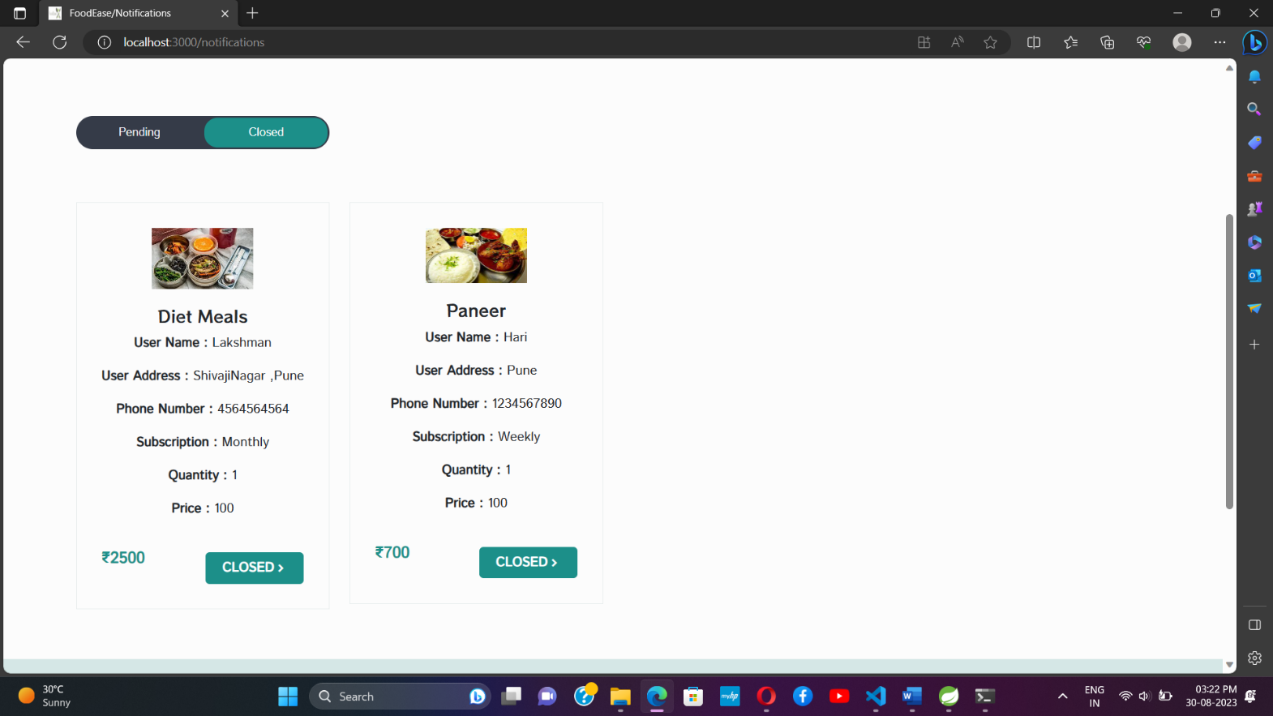

Bill amount

**FUTURE SCOPE AND LIMITATIONS**

**Future Scope and Limitations**

Scope of this project is to provide an efficient platform for people to order

food and keep track of their orders and also to keep track of the food in

the restaurant. In future, the project can be extended to:

1. Incorporate machine learning algorithms for personalized menu

recommendations.

2. Provide in-app payment options.

3. Have a feature for customer feedback and reviews.

4. Add a loyalty program for repeat customers.

5. Integrating with smart home devices for better order management.

**Limitations**

1. Limited to a specific geographic location.

2. Limited payment options available.

3. Limited menu options for customers.

4. Dependent on a reliable internet connection.

5. Limited to food delivery only, not able to cater for dine-in

customers

**CONCLUSION**

In conclusion, FoodEase is a platform that aims to revolutionize the home mess system by providing a convenient and efficient solution for ordering food. It brings together customers, home chefs and delivery partners on a single platform to make food ordering seamless and hassle-free. With its user-friendly interface, advanced security features and integrated payment system, FoodEase offers a complete solution for all food-related needs. However, there is always room for improvement, and the platform is open to future updates and enhancements to better serve the needs of its users.

**References**

* Java Complete Reference by Herbert S.
* Database Programming with JDBC and Java by George

Reese.

* https://Draw.io/
* Wikipedia, URL: http://www.wikipedia.org.
* https://reactrouter.com/
* Google, URL: http://www.google.co.in
* https://start.spring.io/
* https://Javatpoint.com/
* https://www.geeksforgeeks.org/
* https://mysqltutorial.org/